  - Thread Scheduling:
We introduced threads into the process model, distinguishing between user-level threads and kernel-level threads. In operating systems that support both, it is the kernel-level threads that are scheduled by the operating system, not the processes. User-level threads, on the other hand, are managed by a thread library, and the kernel is unaware of them. For user-level threads to run on a CPU, they must eventually be mapped to a corresponding kernel-level thread, often using a lightweight process (LWP) as an intermediary. This section delves into the scheduling issues related to both user-level and kernel-level threads, with specific examples for Pthreads scheduling.

6.4.1 Contention Scope
A key difference between user-level and kernel-level threads is how they are scheduled. In systems using the many-to-one and many-to-many models, the thread library schedules user-level threads onto available lightweight processes (LWPs), which is called process-contention scope (PCS). Here, competition for the CPU happens among threads within the same process. However, the operating system is responsible for scheduling the associated kernel-level thread onto a physical CPU using system-contention scope (SCS), where competition for the CPU occurs among all threads in the system.

Aspect | Process Contention Scope (PCS) | System Contention Scope (SCS)
Definition | Scheduling of user-level threads within a process | Scheduling of kernel threads across the entire system
Who schedules | Thread library | Operating system (kernel)
Competition | Among threads of the same process | Among all threads in the system
Mapping | User threads → LWPs (not directly CPU) | Kernel threads → CPU
CPU Execution | Not directly executed on CPU | Directly executed on CPU
Thread Models | Many-to-One, Many-to-Many | One-to-One
Examples | User-level threading libraries | Windows, Linux, Solaris
Control | Programmer sets priority | OS controls scheduling
Priority Handling | Higher priority thread preempts lower | OS scheduling policies apply
Time Slicing | Not guaranteed for equal priority | Usually supported

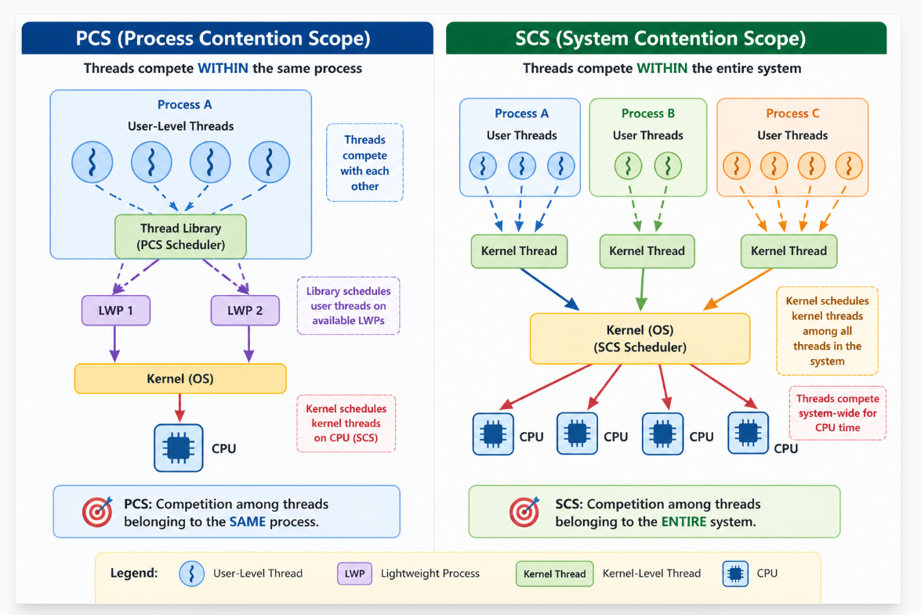

6.5 Multiple-Processor Scheduling
Multiple-processor scheduling is used in systems that contain multiple CPUs or multiple cores. Unlike a single-processor system, where only one process executes at a time, multiprocessor systems allow several processes to run simultaneously using parallel execution. This improves performance, throughput, and CPU utilization. However, scheduling becomes more complex because the operating system must decide which process runs on which processor.
In most systems, processors are identical, known as homogeneous multiprocessor systems. Since every processor is similar, any CPU can execute any process. This provides flexibility to the scheduler. However, some hardware constraints may require a process to run only on a specific processor.
Multiprocessor scheduling is needed to ensure efficient utilization of all CPUs. The scheduler must perform load balancing so that no processor remains idle while another is overloaded. Proper scheduling improves system efficiency and overall performance.
6.5.1 Approaches to Multiple-Processor Scheduling
There are two main approaches to multiprocessor scheduling: Asymmetric Multiprocessing (AMP) and Symmetric Multiprocessing (SMP).
In Asymmetric Multiprocessing (AMP), one processor acts as the master processor. The master CPU handles all scheduling decisions, while the other processors execute assigned tasks. AMP is simple to implement and avoids scheduling conflicts. However, the master CPU may become a bottleneck if too many tasks depend on it.
In Symmetric Multiprocessing (SMP), all processors are treated equally. Every CPU can independently select and execute processes. SMP provides better performance and flexibility, but it is more complex to implement because processors share scheduling responsibilities.

6.5.2 Processor Affinity
An important concept in multiprocessor scheduling is processor affinity. Processor affinity means a process prefers to execute on the same CPU repeatedly. This improves cache utilization because data required by the process may already exist in the processor cache. As a result, memory access time is reduced and performance improves.
Processor affinity is of two types:
- Soft Affinity → The operating system tries to keep the process on the same CPU whenever possible.
- Hard Affinity → The process is strictly bound to a specific CPU and cannot migrate to another processor.
6.5.3 Load Balancing
Another important concept is load balancing. Load balancing ensures equal utilization of processors and prevents some CPUs from being overloaded while others remain idle. Efficient load balancing improves overall system performance.
Two common load-balancing techniques are:
- Push Migration → A busy CPU transfers tasks to an idle CPU.
- Pull Migration → An idle CPU takes tasks from a busy CPU.
6.5.4 Multicore Processors
Modern systems commonly use multicore processors, where multiple cores exist inside a single CPU chip and often share cache memory. Therefore, scheduling decisions must consider cache usage and memory access patterns.
Efficient scheduling improves cache performance, whereas poor scheduling may lead to cache misses, reducing overall system efficiency.

